System Design

Problem 1.1

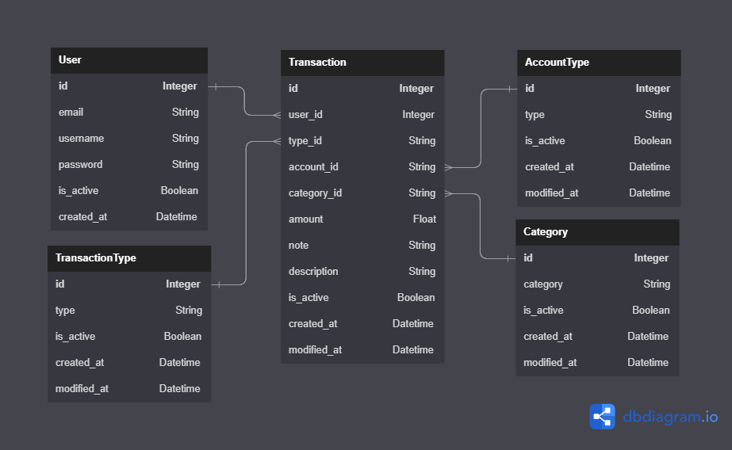

Problem 1.2

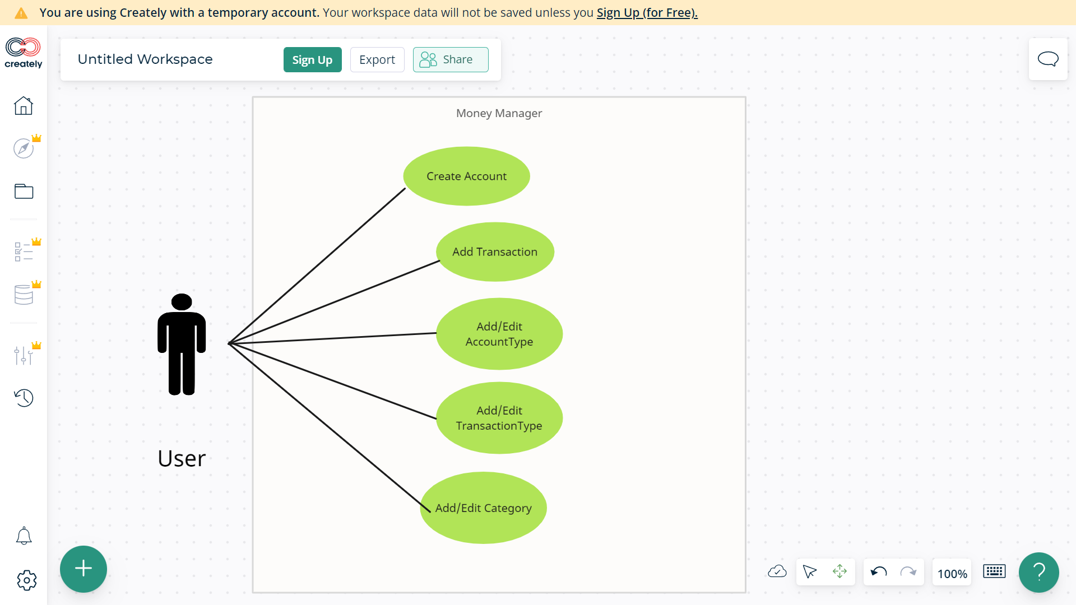

Problem 2.1 (Redis)

KEYS \*

Problem 2.2 (Neo4j)

MATCH (n)

RETURN n;

Problem 2.3 (Cassandra)

SELECT \* FROM User;